



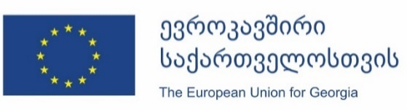

Date: September 17, 2020, 11:00
Venue: Rooms Hotels, Garden Hall (ground floor). Address: 7, Tamar Chovelidze St, Tbilisi, Georgia

Kick-off conference for the Twinning Project GE/18/ENI/HE/01/19
“Strengthening Blood Safety System in Georgia”

Agenda
Time |  | Speakers
11:30 | Registration /  Welcome coffee
12:00 | Welcome speeches  Moderator  Dr. Amiran Gamkrelidze – Director of National Centre for Disease Control and Public Health (moderator) | Ms. Ekaterine Tikaradze - Minister of IDP, Labour, Health and Social Affairs of Georgia (TBC)  Representative of the Delegation of the European Union to Georgia (TBC)  Mr. David Bujiashvili – Director of the EU Assistance Coordination and Sectoral Integration Department, MFA  Ms. Loes Lammerts – Deputy Head of Mission of the Embassy of the Kingdom of the Netherlands to Georgia  Ms. Šarūnė Kubiliūtė – Acting Head of Mission of the Republic of Lithuania to Georgia.  Mr. Daumantas Gutauskas – Director of National Blood Center of the Republic of Lithuania (Video record)
12:30 | Presentations of beneficiary institutions | Dr. Amiran Gamkrelidze – Director of National Centre for Disease Control and Public Health, Project Leader (TBC)  Mr. Martin Smid – Junior Project Leader, Director of Blood Centre Sanquin, the Netherlands
12:50 | Questions and answers
13:00 | End of conference /Lunch

